Smoothie bowl receipe
The good thing about this recipe is you can make it your own. You can add any fruit or vegetables that you prefer into your smoothie bowl. Here is an example of one
of the smoothies I love:
- 32 grams of oats ( I often add oats to mine for slow-release fuel which helps to give me energy)
- Frozen fruit: mango, raspberries, strawberries
- 150ml of milk
- Sunflower seeds
- Almonds
Toppings:
- Fruit: chopped banana and strawberries
- Granola
- Nuts
Method:
- Put all the ingredients in the blender
- Blend it all together
- Pour into a bowl
- And enjoy!

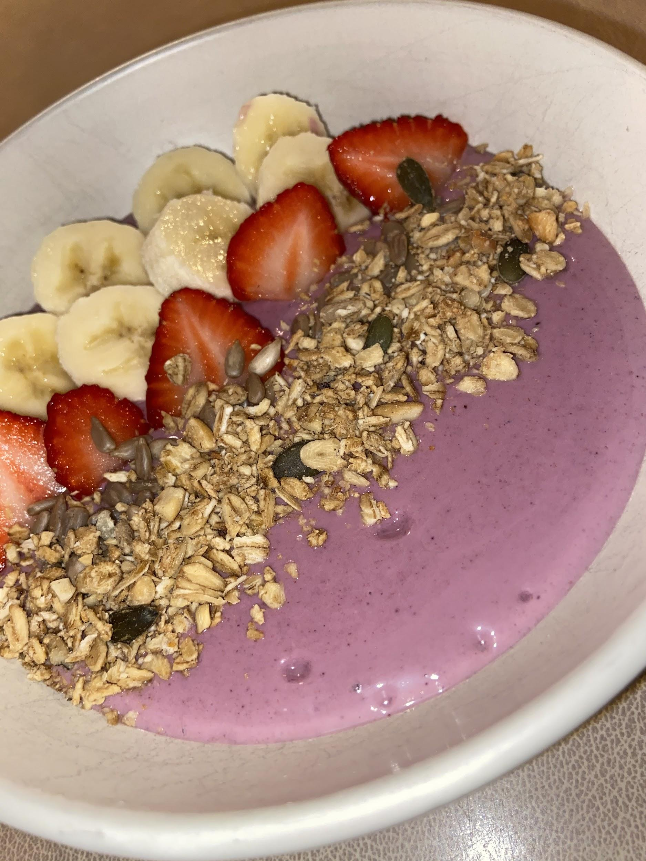

I left the kitchen for 5 minutes and this is what happened…..
