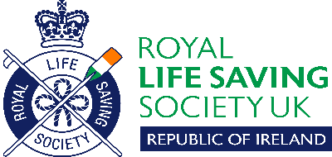
RLSS Ireland Branch
Open Water Surf Life Saving Championships 2021 – Entry Form

Saturday 25th September 2021 – South Beach, Greystones Beach, County Wicklow

 |  |  | Please Tick events required
Name of Competitor | Date of Birth  (if under 18) | Age on day of event | Board Race | Flag | Run- Swim-Run | Rescue Tube Relay | Entry Fee enclosed
1.
2.
3.
4.
5.
6.
Team Manager signature confirming pre-requisites and that competitors have open water experience in the current season _________________________

Contact details, e-mail etc. _______________________________________________________________
Competitors must be a member of an organisation currently registered with RLSS. Competitors must follow Covid 19 guidelines.

Entry fee is €5 per event, or €10 euro for up to 4 events. Please return forms by email by Friday 17th September 2021 to
noelmulhair @gmail.com

No entries will be accepted on the day of the event Please photocopy additional forms as required

RLSS Ireland Branch
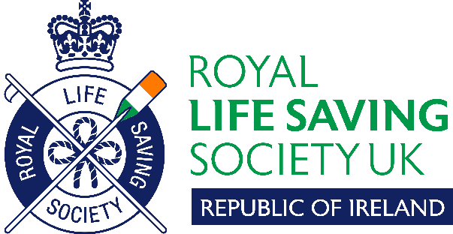
Rescue Board Relay Open Championships 2021 – Entry Form

Saturday 25th September 2021 – South Beach, Greystones Beach, County Wicklow

Name of Club

TEAM |  | Competitor 1 | Competitor 2 | Competitor 3 | Competitor 4 4hh444Reserve (if desired) | Reserve
 | Name
Date of Birth
(if under 18)
 | Name
Date of Birth
(if under 18)
 | Name
Date of Birth
(if under 18)
 | Competitors must be a member of an organisation currently registered with RLSS. Competitors must follow Covid 19 guidelines
Team Manager signature confirming pre-requisites and that competitors have open water experience in the current season

____________________________________________________________________________

Contact details, e-mail etc. _______________________________________________________________

Please return entry forms by email by Friday 17th September 2021 to
noelmulhair @gmail.com

No entries will be accepted on the day of the event Please photocopy additional forms as required

