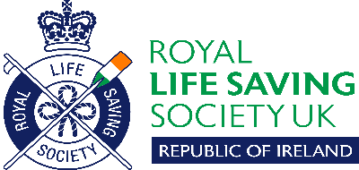
RLSS Ireland Branch
Open Water Surf Life Saving Championships 2021 – COVID-19 Health Questionnaire

Please complete the following questionnaire and email it to your club
before you attend the competition.

Member Name: ____________________

Have you had any of the following in the past two weeks? | YES | NO
- Fever
- Cough
- Shortness of breath
- Difficulty in breathing
- Cold or flu-like symptoms
- Sudden loss of taste or smell
- Diarrhoea
- Sudden loss of energy
- Have you had any contact with a confirmed case of COVID-19 in the past two weeks?
- Have you had a positive test for COVID-19 in the past two weeks?
- Have you travelled outside the country in the past two weeks?

If you have answered YES to any of these questions you should not participate in the competition.

Please sign this form to confirm that the details above are true to the best of your knowledge and to confirm that you understand the risks involved in participation, are participating on a voluntary basis and that you may opt-out at any time.

Member Signature: _____________________________________

Parent/Guardian Signature: _______________________________

Date: _________________________
Please scan your completed form to your club Team/Competitions Manager.

Data Protection Notice

Your personal data is being collected on this form in order to help prevent the spread of COVID-19 whilst participating in the Open Water Surf Life Saving Championships 2021. Your personal data is being processed in accordance with Article 9(2)(i) of the General Data Protection Regulation, and Section 53 of the Data Protection Act 2018. The information you provide on this form will not be used for any other purpose and will be strictly confidential.

