12th September 2023

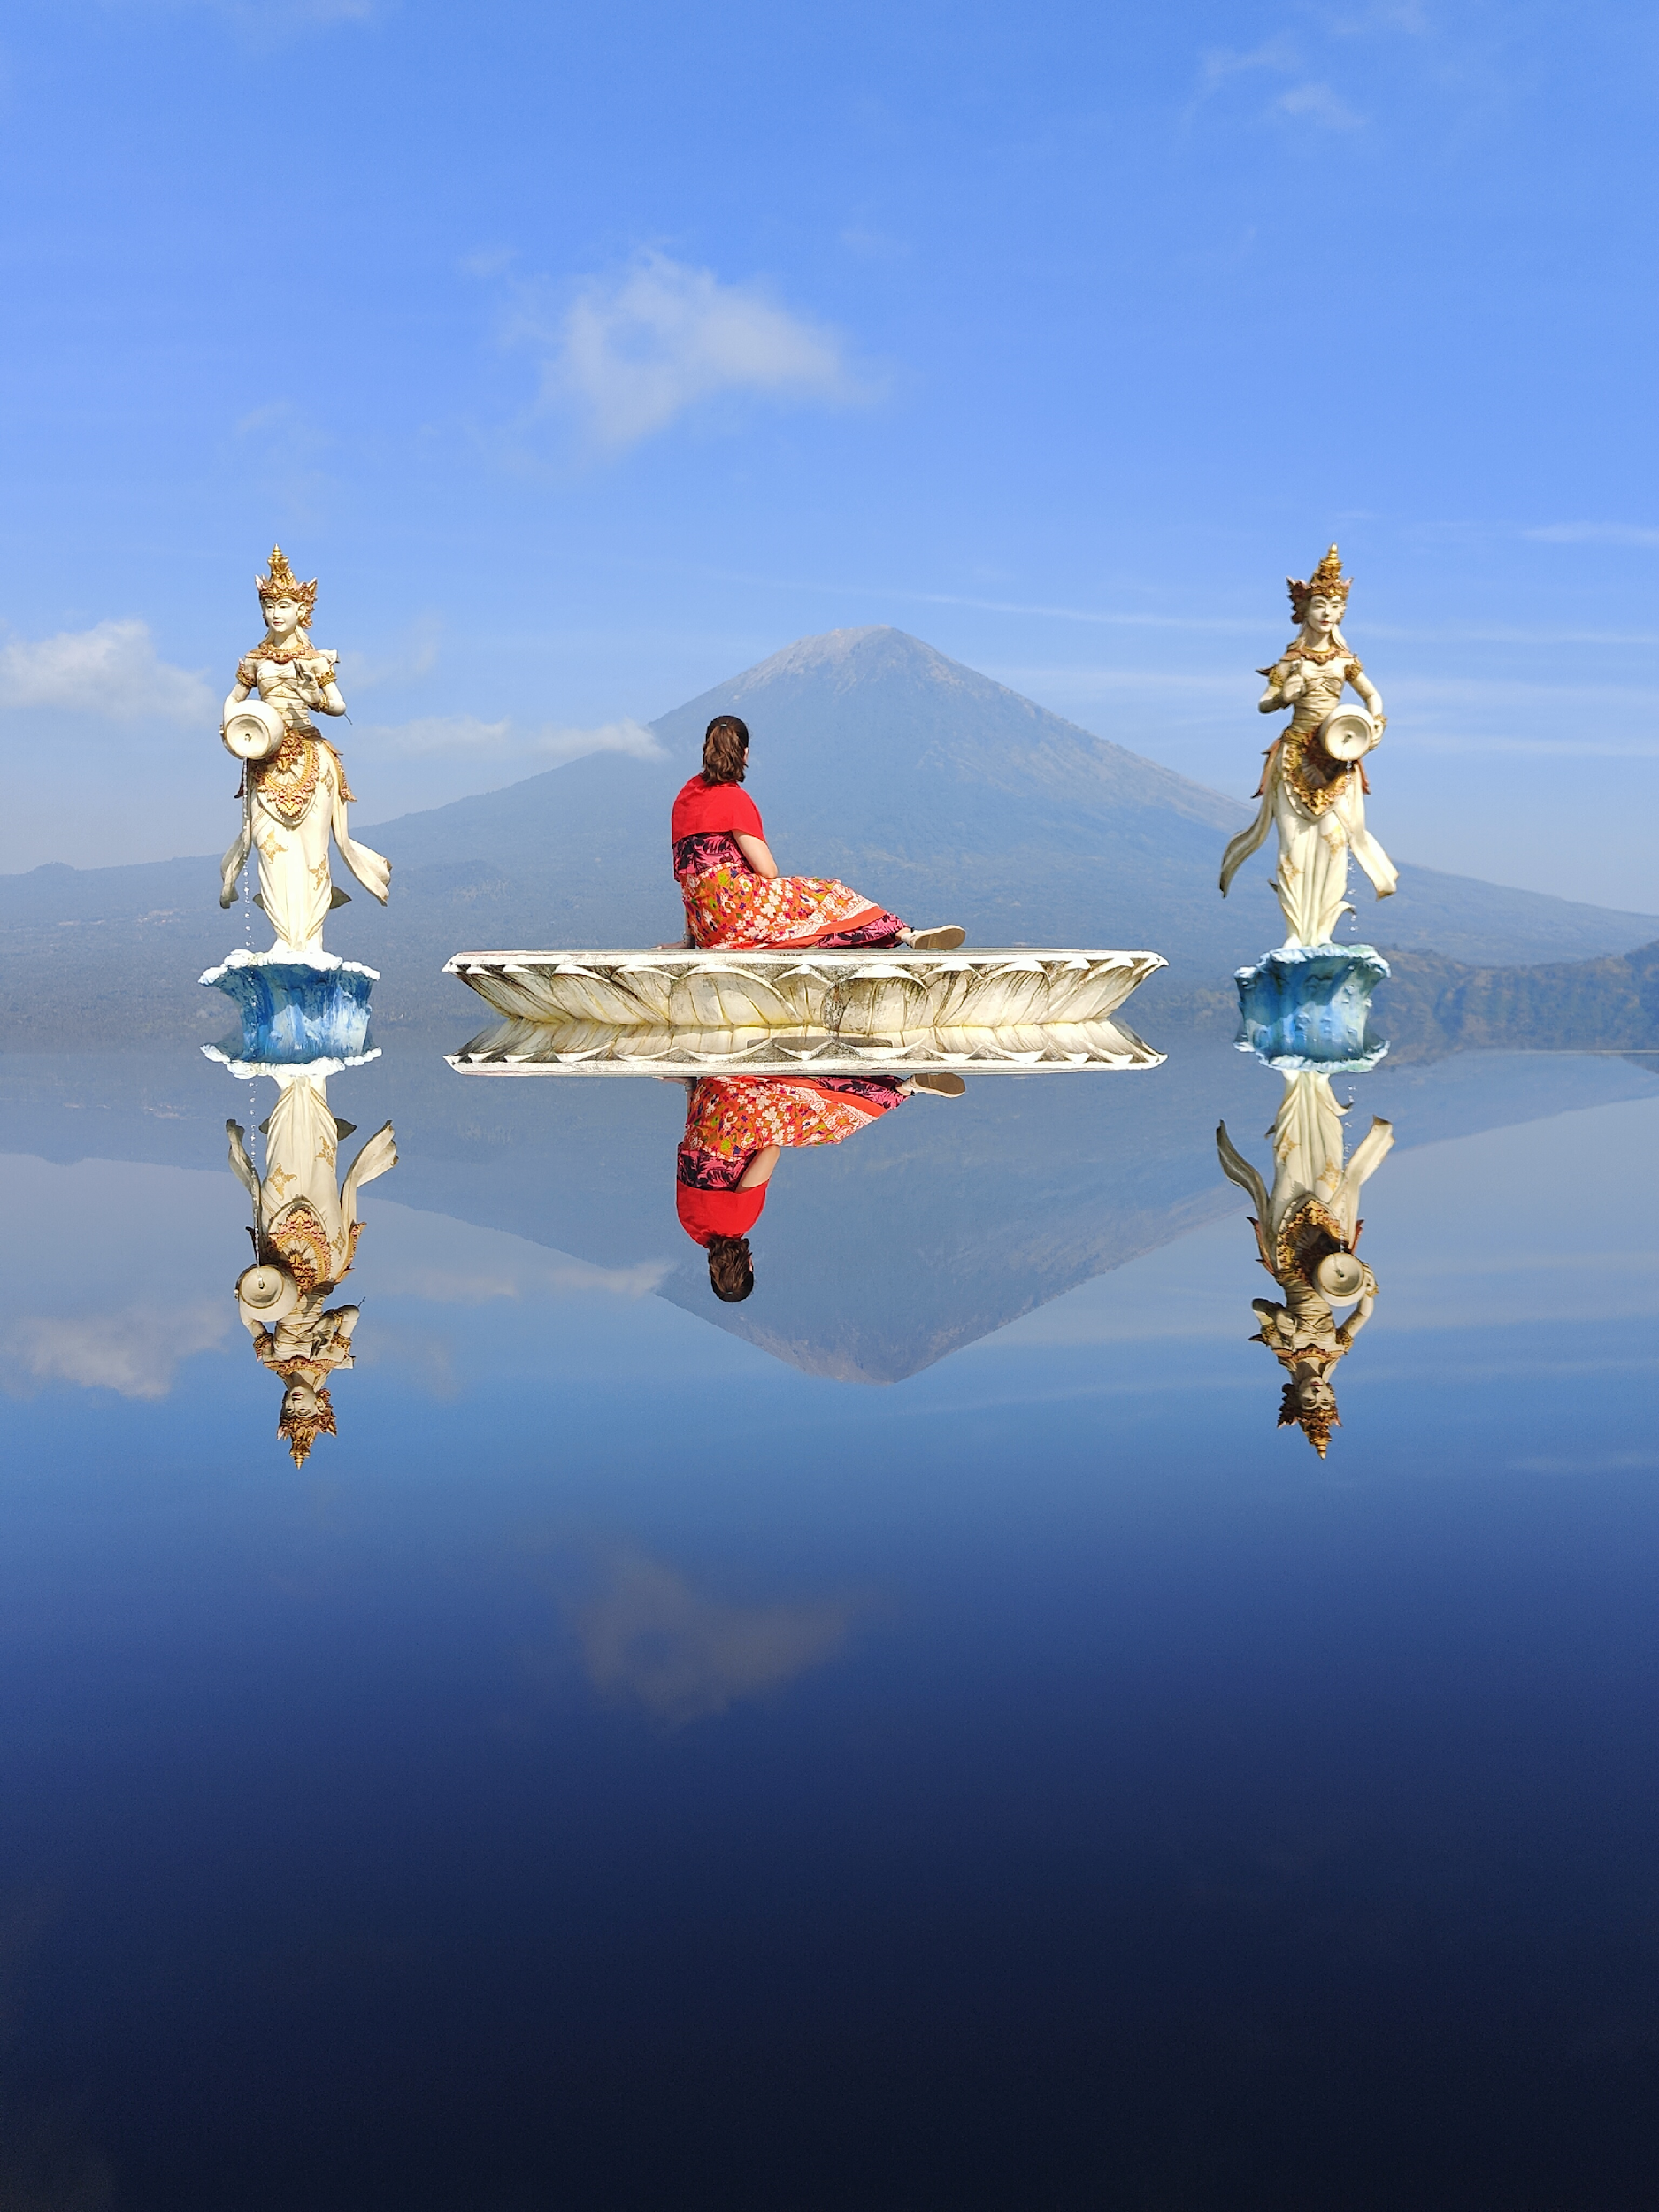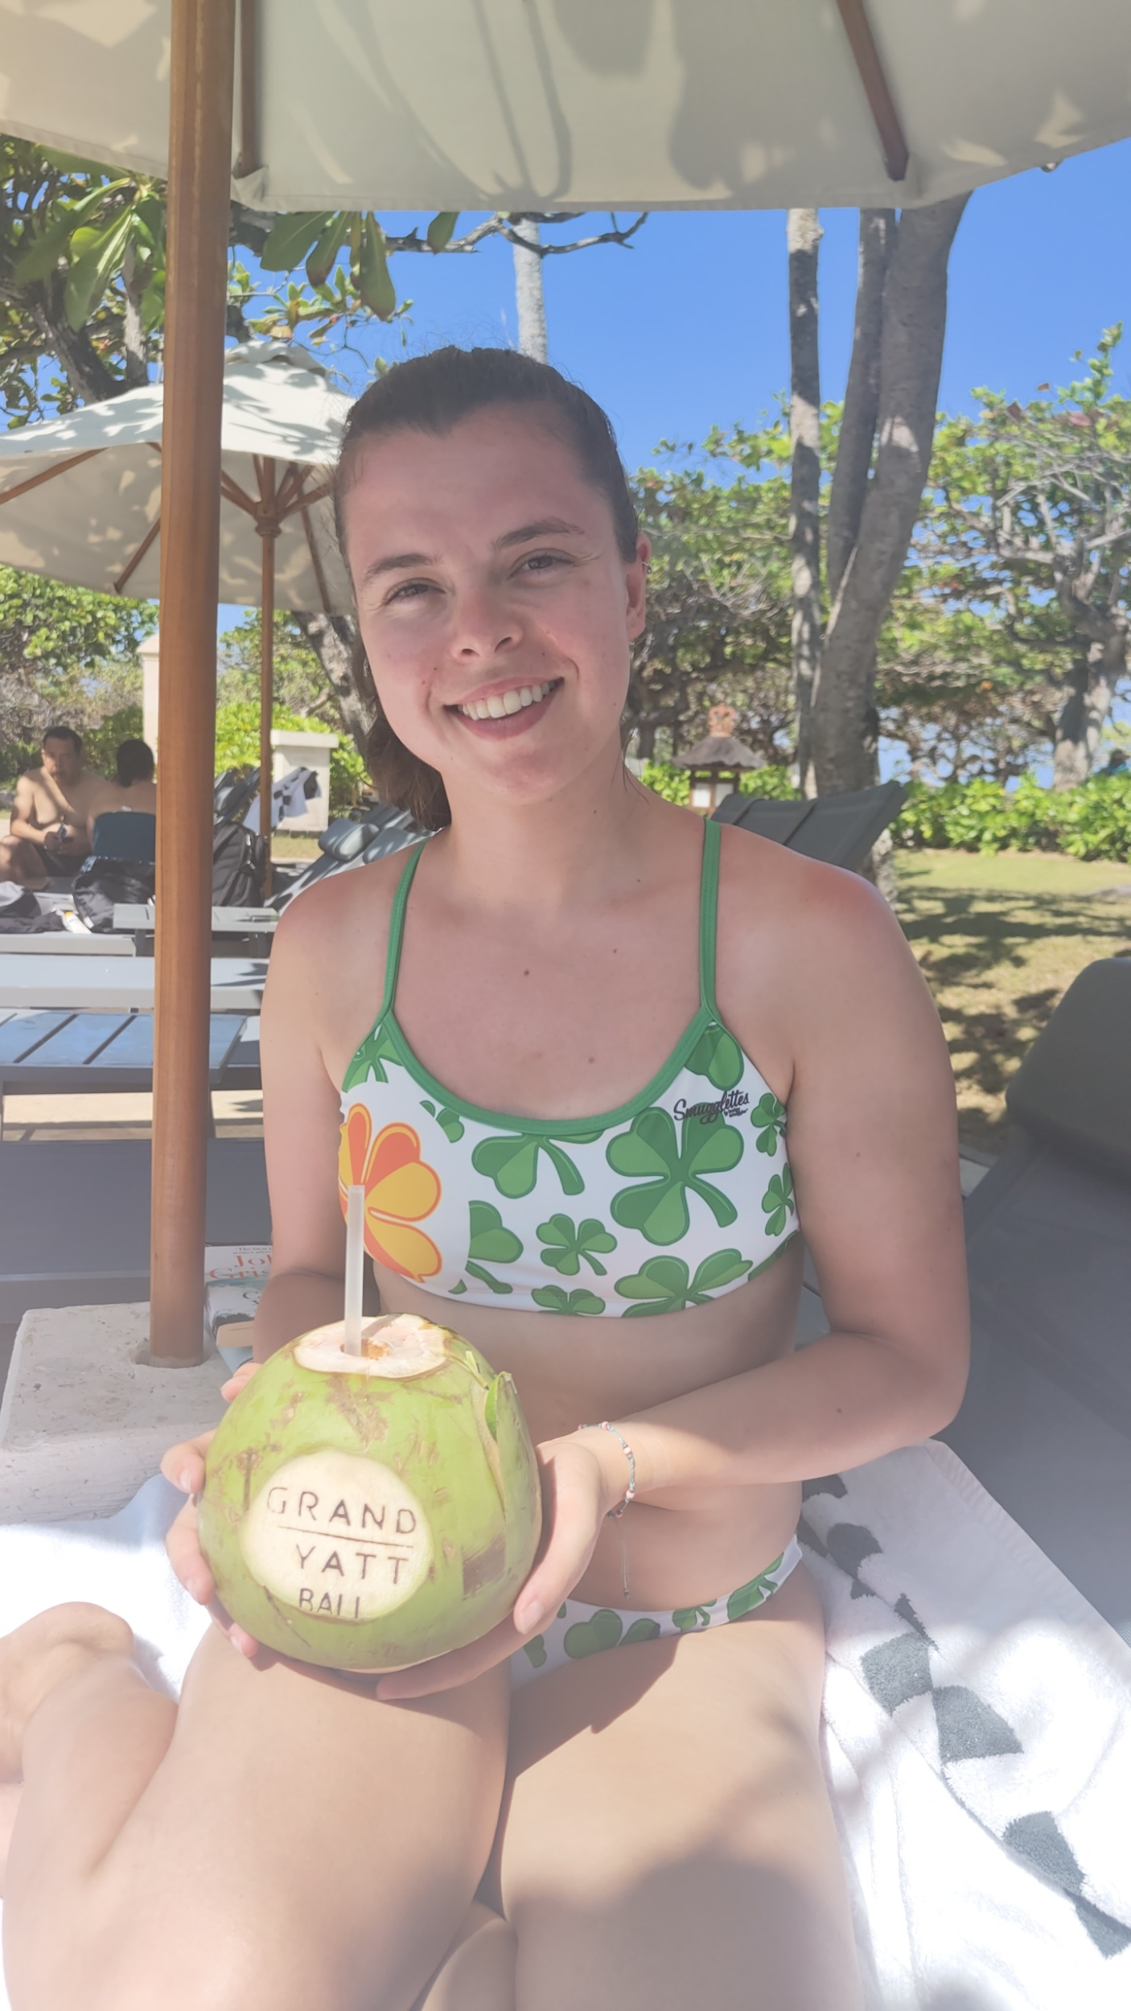

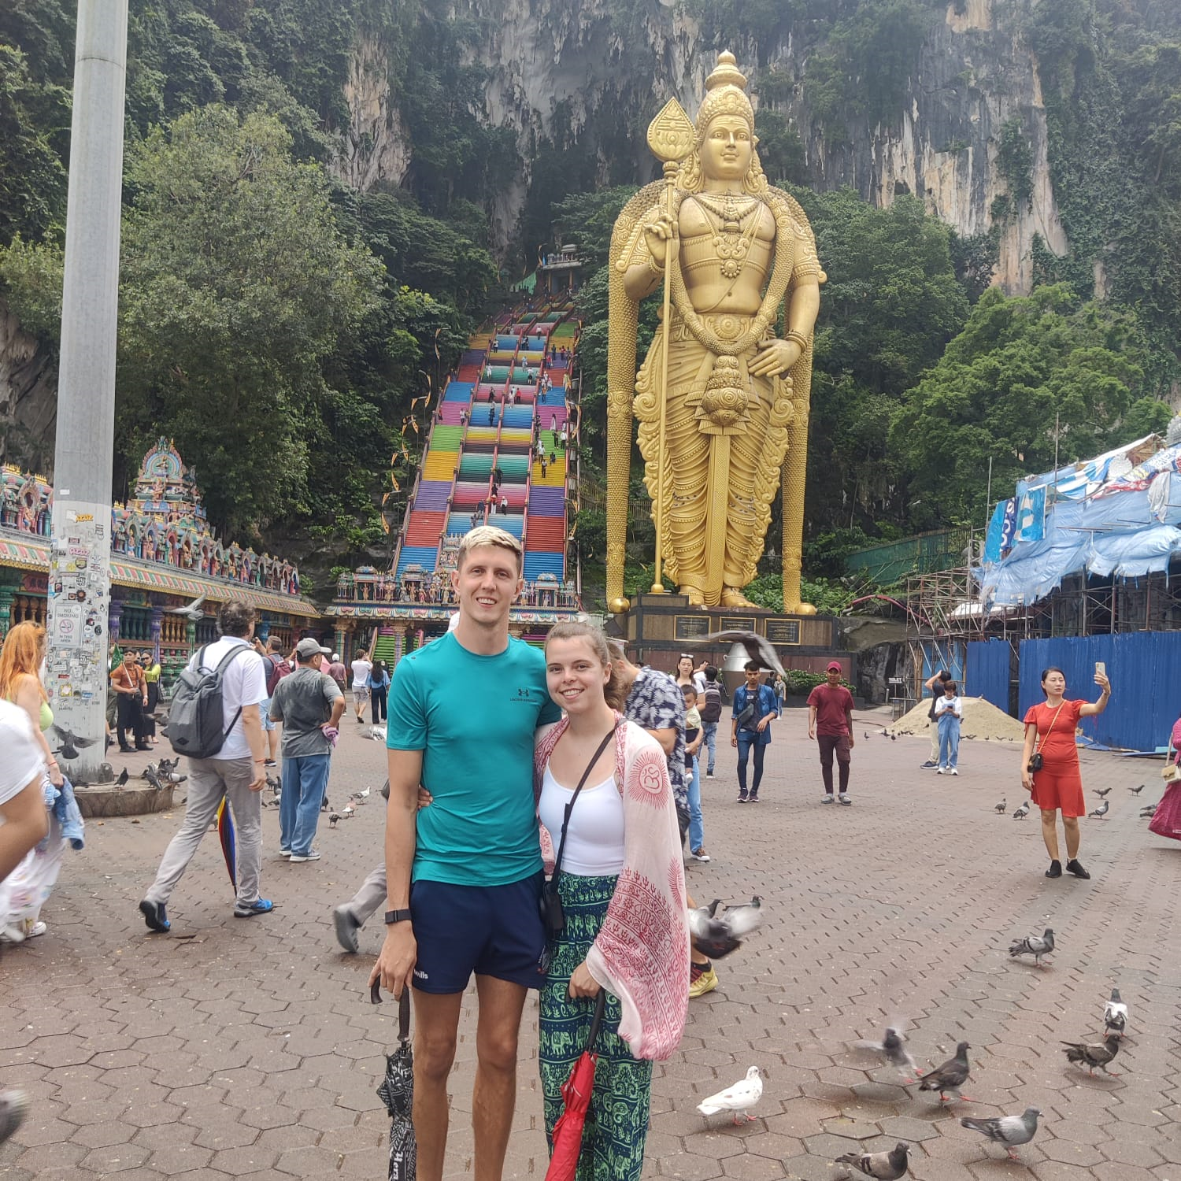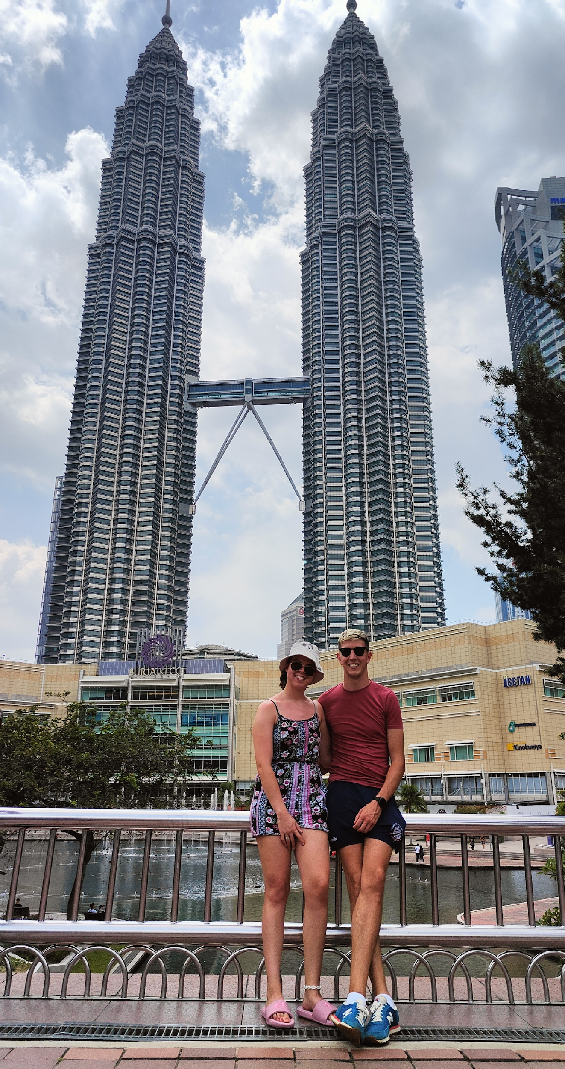

Hey everyone! How are we all?
September has been a very busy month as Brendan and I travelled to Singapore, Kuala Lumpur, and Bali. It was amazing to get some travelling done especially as that has been our biggest trip while out here. Singapore was beautiful but SUPER HOT!! Not a nice heat, more a sticky sweaty heat. The main reason we went to Singapore was for the Formula 1 Grand Prix. This is the first one I have ever been too and wow, what an experience! Post Malone headlined the Saturday night and Robbie Willams headlined the Sunday night and what phenomenal concerts. Brendan and I were both delighted that Verstappen didn’t win the Singapore GP too.
Kuala Lumper was a different cultural experience. The food was absolutely delicious. I have a new profound love for coconut rice, delicious. If you ever have the chance to eat coconut rice, trust me, EAT IT! You don’t need much time in Kuala Lumpur, but it’s a good location for a stop over for a day or two.
Bali is absolutely amazing. The weather, the beaches, the warmth, the people. All I can say is wow. There is so much to see and do in Bali, from tourist attractions to traditional sites. The giant coconuts you can order, filled with fresh delicious coconut water is unbelievable in the 30 degrees heat. Nice and cooling. Bali is the Australian Spain. All Australians go to Bali due to it being so close. We managed to climb Mt Agung which is the tallest mountain in Bali. Little did we know that it would take us 4 hours in the pitch black to hike up to the top!! The sunrise was absolutely stunning. Would I do it again… NO!!!
I start my 88 days farm work on October 2nd. I will be working in Macedon which is only an hour and a half away from where I live. I’m working as a stable hand/groom on a dressage stud farm. Hopefully I enjoy it and the horses are cute. All going well, I should be finished on December 28th, just in time for our trip to Sydney for New Years.
Love,
Ciara

