28th December 2023
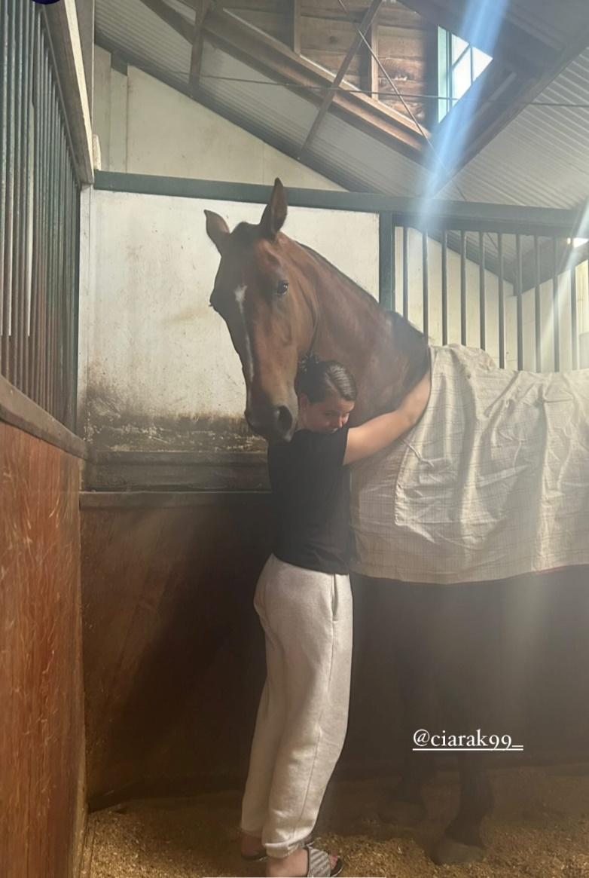
Hello everyone,
I must apologies that I haven’t posted in a while. I have been up on a farm completing my 88 days rural work in order to get my 2nd working holiday visa. I started on October 2nd and officially finished today! I am absolutely over the moon as now I can stay for another year in Australia (provided my visa application is granted).
I was working on a dressage stud farm which had 11 horses that were ridden but in total, on the property, there was approx. 20. Dante (the stallion), Flynn, Froggy, Halle, Fuji, Blackberry, Spider, Kermit, Angel, Cherry, and Bardot were the horses I was working with regularly on a daily basis. Kuri and Matrix were horses that were also ridden when I started but they were sold. My favourites were Blackberry, Kenny, and Kermit. Kermit was a ginormous horse but the absolute definition of a gentle giant. Kenny was a gelding that is up for sale and I will admit, if I had the money, I would buy Kenny. He was the absolute sweetest and so inquisitive and gentle. All he secretly wanted was cuddles and scratches all the time. Management recently purchased a new property which they hope to move to towards the end of the year hence why some horses were sold. They also breed horses but stopped due to COVID but hope to start again sometime this year.
It was an interesting experience as I got to see the inside workings of a competitive dressage stud farm. It was exciting when competition weekend came up as we would have to get the trucks ready for competitors and prepare certain things such as hay bales, feeds, shavings, etc. I will admit though, I am glad to be finished now and back to having Wi-Fi!!!
Brendan and I are off to Sydney to celebrate the New Years. I am really looking forward to seeing the fireworks and of course VISITING BONDI! I hope the weather will be nice too as unfortunately, the Australian summer has not lived up to my expectations. Australians are saying this current summer is very disappointing as its rather wet and we are frequently having thunderstorms.
Hope everyone had a wonderful Christmas and I wish all club members a happy and healthy 2024. May it be filled with joy, laughter, and beautiful memories. I better go and start packing.
Love,
Ciara xxx

